**Husqvarna Global Active Directory Stabilization**

**Ver. 1.0**

## Document version control

|  |  |  |
| --- | --- | --- |
| **Version** | **Date** | **Comment** |
| 1.0 | 29-June | Draft Version |
|  |  |  |
|  |  |  |
|  |  |  |

**Contents**

Document version control 2

1. Introduction 4

2. Objective/End state 4

3. Guiding principal and Key Parameter 5

4. In Scope 7

5. Out of Scope 7

6. Assumptions & Constraints 7

7. Key Milestones & Overall Timelines 8

8. Migration Phase Wise Approach/Activities 9

9. Site Wise Legacy Domain List and Efforts 10

10. RACI for Legacy Domain Migration & Consolidation 11

11. Risks 12

12. Transformation Organization and Governance 14

12.1. Transformation Organization 14

12.2. Transformation Governance 15

12.3. Dependencies on Husqvarna 16

1. Introduction

This proposal describes the scope of work for Husqvarna Active Directory Domain stabilization for the Global active Directory domain. Assessment has been done in the Global AD to find the GAP’s as per the industry standard and the tracker has been created for the identified GAP’s. This Appendix sets out the high level scope, approach, and processes for the Active Directory stabilization in Global AD.

1. Objective/End state

HCL will Migrate the Servers from the 35 legacy Active Directory domains which is identified for the for the AD consolidation. The List of domains for the consolidation is mentioned in the section Site Wise Legacy Domain List and Efforts of this document. In-Scope activities in the below document in a manner that will achieve the following objectives and results:

* The Migration activities in the document only refers to the Servers and Domain Controllers which is member of the domains mentioned in the Domains and Efforts section.
* The common objective is to start the domain consolidation of 35 legacy domains in scope by Sep 2016
* This Migration will help in future to achieve the single forest Single domain Model for Husqvarna, however the domains in scope for migration is 35 Legacy domains.

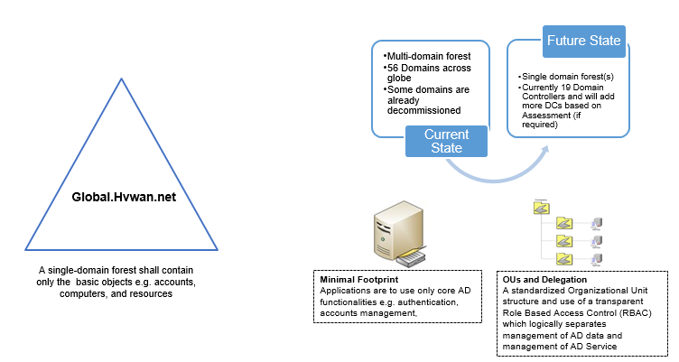

* A secure Active Directory environment for the operation of Husqvarna Active Directory services for productive and significant performance.
* There will be decrease in the number of domain controllers as the Legacy domain controllers will be decommissioned.
* Add the domain controllers in the required sites to improve the performance for the end users.
* Ease to manage the domain objects/administer in the Global domain.
* RBAC – OU level delegation the existing administrators/support groups to manage the resources in global AD.

1. Guiding principal and Key Parameter

As part of Legacy domain consolidation, 35 legacy domain (see below table) where HCL need to perform the consolidation which includes Migration, Consolidation & Decommission based on the Server and application assessment and co-ordinate with application owners to mitigate the risk and migrate it to the global domain.

For legacy domain consolidation in Husqvarna, some of the key parameters that HCL assume will play a key role are:

* Number of users per site
* Application Owners
* Domain dependency of the application
* Application remediation

The guiding principles for these legacy domain consolidation have been listed as below.

* Migration of member servers from Legacy Domains to global domain.
* Decommission the 35 Legacy domains.

**Current Environment Statistics**

* Total number of Domain to migrated : 35
* Total Number of User accounts 21179
* Total Resources: 1600
* Total Number of Server to be Migrated: 600

The Following is the domain wise Users, Computers and Server objects from the legacy domains, only the active windows servers (Approx. 600 Servers) in the legacy domains is assumed to be in scope, subject to further detail feasibility study.



1. In Scope

Following high level in scope activities involved in transformation:

* Assessment of Legacy domain infrastructure
* Assessment report
* Planning the site migration schedule
* Production testing and piloting
* Production migration
* Co-ordinate with application team for the application remediation
* Migrate the DNS zones from the legacy domains to the Global DNS Servers
* Migrate the DHCP servers from the legacy domains to the Global domain.
* Migrate the file servers and reACL the file servers
* Post migration support
* Decommission of Legacy domains

1. Out of Scope

Following high level out of scope activity, where Husqvarna help needed

* User Migration and group migration
* Application migration and remediation
* Procure the migration tool if in-case of Quest is selected as Migration tool.

1. Assumptions & Constraints

Following activities assumed to be managed by Husqvarna or aligned SPOC

* HCL assumes that the Users, Groups and Workstations are migrated from all the domains and if any users are still using the legacy domain credentials it is responsibility of Husqvarna to migrate the users to Global domain.
* Husqvarna already migrated all users and security groups from the legacy domains will be re-migrated and merged with respective Global domain objects (which were migrated previously) so that servers can be ReACLed with same tool (Dell Migration Manager / ADMT).
* “Dell Migration Manager for AD/ADMT” will be used to perform AD migration and security translation of servers.
* If the ADMT is used as Migration tool, the input will be used to reACL the file servers.
* The Quest migration manager will be procured by the Husqvarna if in case it has been selected as the migration tool.
* Dell migration manager for active directory tool and associated infrastructure to install and configure the tool (If QMM is selected as migration tool).
* Site wise assessment for planning and respective HW/virtual for new Domain Controller to accommodate new users (if needed).
* The File Servers will be migrated AS IS migration and there will not be any change in the folder restructuring during this migration.
* Group Policies and Login Scripts are already copied over from legacy domain so no change will be done for this.
* There will be several other unidentified applications in legacy domains that requires modification to support co-existence phase so those applications need to be remediate. Application remediation will be out of scope for this project.
* In active windows servers there will be several application servers that are not AD dependent and we may need to involve other teams like Wintel/Apps teams etc.
* Efforts are calculated based on 35 legacy domains analysis and it may increase based on actual number of domains.
* Application level hardcoding for the Domain/Domain Controller/File Shares has to be modified by the respective stakeholders during the migration.
* Network devices (Wireless Access Points/Firewall devices which ever is pointed to domain authentication has to be pointed to Global domain during the migration.

1. Key Milestones & Overall Timelines

The following shows the key milestones and overall timelines for the 35 legacy domain consolidation.

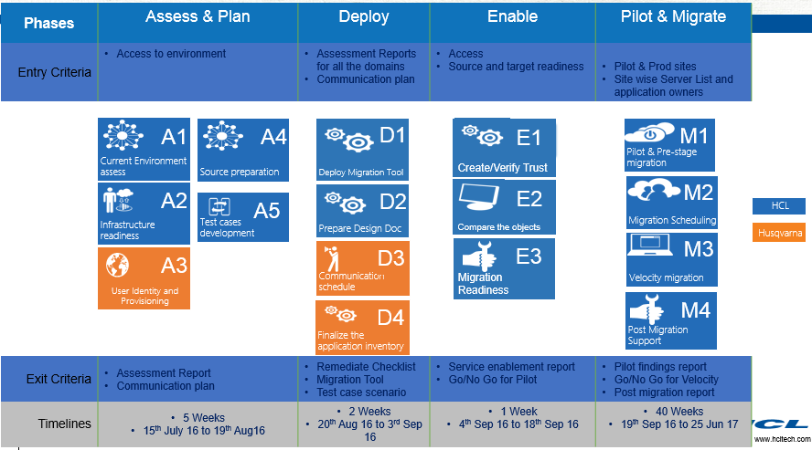

1. Migration Phase Wise Approach/Activities

The following phase’s shows the detailed migration phases and activities will be done by HCL for the domain consolidation.

**Assessment and Planning Phase**

* Identification of key stakeholders
* Current environment Assessment
* Customized scripts will be used to take the AD reports for the better comparisons
* Assessment of users, resources and Servers in each domain
* Soft match of users and groups – Already migrated
* Trust relations assessment and validation
* Assessment report for each domain
* Review with Husqvarna for approval
* BOM finalisation for Tools and migration infrastructure
* Identification of Pilot Domains
* Planning

**Deploy and Test Phase**

* Infrastructure reediness for Migration
* Tools deployment and configuration
* Test the tools functionality
* Test cases and UAT
* Performing the test cases and sharing the results with Husqvarna
* Sign of for the test

**Pilot Phase**

* Identification of the Pilot domains
* Create appropriate Changes for the Pilot
* Approval from Husqvarna for the down times
* Pilot
* Pilot results
* Sign of the pilot

**Production Migration Phase**

* Validating the pilot results and issue fixing
* Scheduling the productions migrations
* Piloting for each Domain
* Pilot results
* Acceptance
* Required changes in place
* Production migration
* Sign off for each domain

**Post migration support and Decommission**

* Setup monitoring of old domains to ensure complete migration (Change Auditor)
* Monitor domain when basic migration is done
* Setup and operate activity reporting per domain
* Setup and operate Domain Controller status reporting
* Initiate and track final retirement of Domains
* Shut down the domain controller
* Decommission

1. Site Wise Legacy Domain List and Efforts

The following is the list of domains in AD consolidation scope and the list of active servers from each domain based on the data pulled from Active Directory. The domain wise timelines will be proposed after the assessment phase.



1. RACI for Legacy Domain Migration & Consolidation

|  |  |  |
| --- | --- | --- |
| Pre-Migration Activities | Husqvarna | HCL |
| Prepare Migration Checklist for Pre, Execution and Post phase | C/I | R/A |
| Prepare Migration SOPs on basis of executed test scenarios | I | R/A |
| Prepare Technical Design Document for each Domain/Forest | C/I | R/A |
| Install and configure the QMM Migration Manager Servers | C/I | R/A |
| Review of test results by Husqvarna team after successful migration of users in the Lab | R/A | I |
| Domain/Domain/Forest specific User, Groups and Object list for Merge using QMM | C/I | R/A |
| Migrate/Merge Groups/Users from all Source Domains to target Domain | C/I | R/A |
| Security translation on all Servers | C/I | R/A |
| Domain specific Server hardware assessment & compatibility list for Migration | C/I | R/A |
| User notification/communication | R | R/A |
| Domain specific assessment report for Migration | I | R/A |
| Domain/Forest specific Technical Design Document with Migration approach | C/I | R/A |
| **Dell Quest Migration Manager (QMM) Readiness** | **Husqvarna** | **HCL** |
| Installation of QMM Server | C/I | R/A |
| Configuration of QMM Console | C/I | R/A |
| Give the QMM service account Administrator rights on all Servers | R/A | R/A |
| Installation of QMM Agent on target Domain Controllers | C/I | R/A |
| **Active Directory – Deployment Activities** | **Husqvarna** | **HCL** |
| Windows Server hardware Procurement | R/A | C/I |
| Windows Operating System installation on physical Servers | I | R/A |
| Promote the servers as Additional Domain Controller in to Global AD Domain. | C/I | R/A |
| Reconfigure the DNS and DHCP structure. | C/I | R/A |
| Merge of all the Users, Groups, Permission and Objects in to Global AD Domain. | C/I | R/A |
| Check required permissions for Migration Account | C/I | R/A |
| Create service accounts and reconfigure applications to use them | C/I | R/A |
| Migrate Servers and associated Service Accounts | C/I | R/A |
| Update DHCP Scopes to use the new Domain Controllers | C/I | R/A |
| Once all users are migrated, update permissions on File Servers, Application Servers, Print Servers etc. removing entries for old objects | C/I | R/A |
| Schedule the list of servers to be migrated | C/I | R/A |
| Communication about the Migration schedule to local IT helpdesk team or End user | R/A | R/A |
| Security translation of File and print servers | C/I | R/A |
| Verify migration log | C/I | R/A |
| Fix any issue (login, domain authentication, profile, permission etc.) which is reported by user related to migration of Domain | C/I | R/A |
| Fix any issue (Replication, DNS resolution, DHCP etc.) which is reported by Domain/Forest related to migration of Domain. | R/A | R/A |
| **Active Directory – Configurations** | **Husqvarna** | **HCL** |
| Defining the domain structure and determining server properties | C/I | R/A |
| Creation and Modification of Sites and Site Links. | C/I | R/A |
| Ensure the replication convergence for all DCs. | C/I | R/A |
| Setup DFS or DFSR if required | R/A | R/A |
| Configure and install AD integrated DNS services. | C/I | R/A |
| Reconfiguring DNS structure as per design document | C/I | R/A |
| Reconfiguring DHCP structure as per design document | C/I | R/A |
| Check all setting as per LLD document like security setting etc. | I | R/A |
| Ensure the replication convergence for all DCs | C/I | R/A |
| Check DNS replication in newly promoted domain controller with existing DCs | C/I | R/A |
| Check stub zone is replicated properly with new DC. | C/I | R/A |
| Reconfigure all DNS setting for NIC on Each DC ( it should be mapped with new DC) | C/I | R/A |
| **Decommissioning** | **Husqvarna** | **HCL** |
| Decommission old Domain Controllers / Degrade of Old Domains | C/I | R/A |
| Remove DNS records for old Domain Controllers | C/I | R/A |
| Support Post migration issues if any | C/I | R/A |

1. Risks

The following are the list of Risks and mitigation plan.

|  |  |  |  |
| --- | --- | --- | --- |
| **Risk Category** | **Anticipated Risks** | **Impact Description** | **Mitigation Plan** |
| Engagement -Resource/Technical Readiness | Lack of availability of subject matter experts (SMEs | Project delays. Deployment mistakes due to unqualified staff. | Publish the holiday calendar and apply senior management support to secure SME availability |
| Engagement -Timelines | Inadequate time allocated for design, build and migrate | Project delays. Post Implementation issues. Poor User experience | Document all the requirements and map all those requirements to the use/test case and allow sufficient time and people to test, verify and validate whether the solution is fit for the purpose |
| Technical - Timelines | Non-availability of the application owner to perform the UAT | Project delay. | Engage the App owners early through a proper communication in order to allow sufficient time and bandwidth to provide sign of on UAT |
| Engagement -Business Readiness | Lack of proper business change management | Delay in approvals from business and lack of trust regarding the new transformation | Business change management needs to be factored and planned as an integral part of the program |
| Application compatibility | Some 16/32 bit applications not compatible with windows 2008 Domains | Application remediation need more effort and delay migrations | Application remediation can be done by code change |
| Dell migration manager DB corruptions | Dell Migration manager store data on SQL DB | Single point of failure and lose all migration data | SQL cluster and regular backup of project data |
| Parallel projects | Dependent projects delays like exchange /SharePoint migrations | Project will get delayed due to other ongoing projects | Need to coordinate with all dependent project owners |
| Improper GPO implementation | Wrong Linking of Group policies leads to security risks | Project delay due to manual trouble shooting | Proper testing of GPO’s before moves to production |

|  |  |  |  |
| --- | --- | --- | --- |
| **Risk Category** | **Anticipated Risks** | **Impact Description** | **Mitigation Plan** |
| Technical - Resource/Technical Readiness | Lack of a lab environment that closely represents the production environment. | Staff lacks hands-on deployment experience. Invalid proof of concept or validation. Production deployment results will be unreliable. | Acquire the required hardware in advance of the project start date. |
| Technical -Resource/Technical Readiness | Necessary hardware and resources (like firewall opening etc.) not done on time | Project delays. | Identify and capture the requirements which have an external dependency early in the project and flag off for approvals |
| Technical - Operation Readiness | Network architecture may not be adequate to allow speedy deployment or provide all planned functionality | Project delays. Poor deployment performance. | Ensure that network architecture is adequately prepared. For example, deploy QMM servers close to receiving workstations |
| Technical - Operation Readiness | Non – Connectivity of Husqvarna environment to HCL offshore team | Project delay and cost increase due to increase in onsite | The Infra and connectivity needed will be planned well in advance and will be closely tied to dependencies |
| Migration of Win 2000 WS / Server | Migration of Win2k Workstation and Servers not supported by QMM | Project delay due to manual effort | Need to Upgrade to Win7 / Windows 2003 /2008 |
| Corrupted AD data in source domains | Corruption of NTDS.DIT in the source domains | Delay in the project fixing of data need more time | Regular backup and validation of NTDS.DIT |
| Manual mapping of profile post migration / access issues post migration | Post migration some users profiles don’t map automatically | Manual profile mapping take more time | Proper matching old and new SID. Automation using ini files |

High

Medium

Impact Level

1. Transformation Organization and Governance
   1. Transformation Organization

|  |  |
| --- | --- |
| Governance Layer | Responsibility |
| Executive Steering Committee | * Act as the owners of the Transformation Project’s vision and business case, ensuring the Transformation Project continues to present a compelling case for change and is aligned with the Husqvarna’s overall strategy * Act as a champion for the Transformation Project, providing ongoing commitment to and endorsement of the Transformation Project objectives to enable its completion within the agreed budget and timescales * Act as challenge to the Transformation Project in terms of scale of ambition, credibility of business case and robustness of program disciplines and approach * Resolve strategic and interdependency issues within the Transformation Project * Ensure cross Transformation Project risk is effectively managed and mitigated * Confirm successful delivery and sign off at the end of major phases, and approve initiation of new phases of the Transformation Project e.g. vision, design, implementation, close etc. * Support the Transformation Project in freeing resource and unblocking issues that have been escalated by the Transformation Project Board * Support the Transformation Project in managing, completing program and business as usual priorities * Monitor and approve significant changes to scope, budget and time line |
| Operational Steering Committee | * While the Executive Steering Committee is responsible for setting the overall direction, and program forward and ultimately delivering the benefits to the agreed budgets and timescales * Members of the Operational Steering Committee are accountable:   + Confirm successful delivery and performs Critical Milestones sign off in accordance with above Transformation Project Acceptance Process   + Pre-approve and prepare Executive Steering Committee decision material for significant changes to scope, budget and time line   + Ensure the program delivers within its agreed parameters of scope, risk, impact, time, cost and benefits   + Provides Critical Milestone sign off   + Ensures that risks and issues are effectively identified and resolved, as well as cross program issues   + Resolve cross project interdependencies, resourcing and integration issues   + Acts as Change Control Board   + Provide assurance for business as usual stability during the life of the Transformation Project   + Represent local issues in as far as they affect the program   + Ensure appropriate escalation to the Executive Steering Committee. |
| Joint Operational Steering Committee | * Provides additional input and support to the Transformation project to ensure smooth transfer of responsibilities between the parties * Ensures that significant project issues are identified and resolved between parties * Ensures that project risks are effectively managed and mitigated between parties |
| Transformation Operational Team | * Owns the responsibility for planning and completion of Transformation Project Plan * Be responsible for timely Transformation of the respective phases * Provides Key Milestone sign off * Reviews all volumes of assets, incidents reported, service levels and contractual commitments for the respective tracks * Ensure the Project delivers within its agreed parameters of scope, risk, impact, time, cost, quality and benefits * Initiates and higlights requirements related to significant changes to scope, budget and time line * Maintains robust change control procedures * Responsible for driving risks and issue management and resolution * Working with the Husqvarna’s delivery team on day to day operations for any clarifications and Transformation discussions * Facilitate HCL in providing the relevant information pertaining to track specific information * Provide access to the documentation, SOPs, and past data as required * Effectively take part in discussions and playback sessions to validate and approve the volumetric, and delivery specific information |

* 1. Transformation Governance

Following is the Transformation Governance to be implemented during the Transformation period of Legacy Domains and associated.

|  |  |  |  |  |
| --- | --- | --- | --- | --- |
| **Meetings/ Reviews** | **Frequency** | **Accountable Participants** | | **Meeting Ownership** |
| **Husqvarna** | **HCL** |
| **Executive Steering Committee** | Monthly | * CIO * IT Service Head * Sourcing/ Vendor Manager * Manager Service Operations * Program Manager | * Delivery Head - CE * Program Director * Transformation Program Manager * Infra Account Manager | Sourcing/ Vendor Manager (Husqvarna) |
| **Operational Steering Committee** | Every 2 weeks | * Program Manager * Transformation Manager * Manager Service Operations * Sourcing/ Vendor Manager * Architecture & Innovation Head | * Program Director * Transformation Program Manager * Infra Account Manager * Architecture/ Transformation & Innovation Lead | Program Manager (Husqvarna) |
| **Operational Project Meeting** | Weekly | * Transformation Manager * Track leads * Technical Leads (Husqvarna or Incumbent) | * Transformation Program Manager * Project Manager per sub-project * Technical Leads | Project Manager (HCL) |

As a minimum the following documentation must be available for each meeting:

* Minutes from previous meeting
* Overview of next period’s activities
* Transformation status overview per tower (including issues list – RAG)
  + Issues list
  + Actions list with ownership
  + Change requests to be processed (Including description of financial impact)
* Updated financial overview
* Updated project plan (relevant level of detail)
* Updated risk assessment
* Executive overview (Executive Steering meetings only)
  1. Dependencies on Husqvarna

Following are some of the key dependencies on Husqvarna:

* Actively participate in periodic steering committee/ review meetings – review progress as well as intervene to facilitate resolutions
* Need to nominate a PMO Team from Husqvarna
* Ensure Husqvarna / Vendor SME time is provided. HCL will take all efforts to provide this requirement in advance.
* Husqvarna will allow HCL to use their office facilities and premises (e.g. seats, desk phone, desk LAN or Wi-Fi, meeting rooms, cafeteria, etc.) during Legacy Domain Consolidation.
* Physical and logical access for HCL has to be arranged during this phase to ensure smooth knowledge transfer.
* Husqvarna to complete internal communication immediately to respective stakeholders post Effective Date
* Review and approve any additional logistics and swing requirements highlighted by HCL